**510 Calibration Software Installation**

**NOTE**: Do not connect 510 Calibration box, TL1188, until the LV19 Runtime environment is installed.

(Install time for LV19 Runtime is approximately 15 minutes)

**NOTE**: Installation of the 510 Calibration software requires an internet connection.

Table of Contents

LV19 Runtime Environment Installation 2

510 Calibration Interface Installation 3

510 Calibration Interface Setup 5

Task Setup 6

Create an Output Task 6

Create an Input Task 10

510 Calibration Set-up – “Viatran Adjust” Software 13

**Table of Figures**

Figure 1 Destination Directory for LV19 Runtime Environment 3

Figure 2 USB-6009 in Device Manager 4

Figure 3 NI MAX Icon 5

Figure 4 Measurement and Automation Explorer Start Screen 5

Figure 5 Verify NI USB-6009is present 6

Figure 6 Create New 7

Figure 7 Create New → Digital Output 7

Figure 8 Create New → Channel 8

Figure 9 Create New → Port0_Out 9

Figure 10 Create Task 10

Figure 11 Acquire Signals -→Digital Input → Port Input 10

Figure 12 Create New → Channel 11

Figure 13 Create New → Port1_In 12

Figure 14 "Port0_Out" and "Port1_In" Should be Listed 13

# 

# LV19 Runtime Environment Installation

1. Using supplied media (flash drive), navigate to \**LV19Runtime_Installer\My Installer\Volume Folder**.

2. Double click on the **SETUP** application in the volume folder to begin installation. Accept the license agreements.

3. The installer will display a screen showing where files will be stored. Select **Browse** to change the location or **Next** to accept this location. (See **Figure 1**) Install time is approximately 15 minutes.

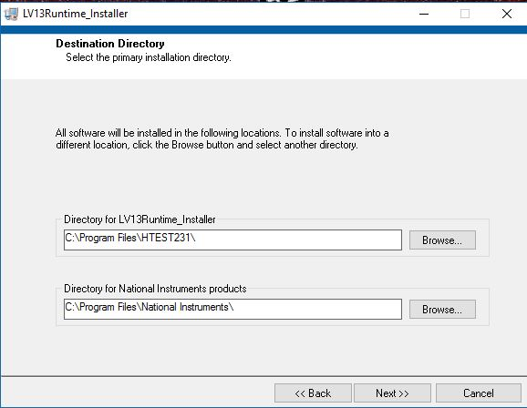

**Figure 1 Destination Directory for LV19 Runtime Environment**

4. When prompted restart computer to successfully complete installation.

# 510 Calibration Interface Installation

5. On the supplied media (flash drive), navigate to \**LV19Runtime_Installer\My Installer\Volume Folder**.

6. Attach **510 Calibration Box** to the computer via USB Cable.

1. Let unit install. “**Device Detected**” will be displayed momentarily upon completion.
2. To verify the module has successfully installed…
   1. Using the **Device Manager**, find the category labelled “**Data Acquisition Devices”**
   2. Expand **“Data Acquisition Devices”** and verify“**USB-6009**” is listed. (**See Figure 2**)

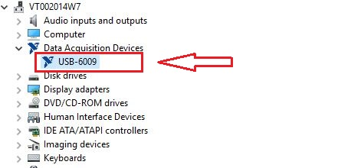

**Figure 2 USB-6009 in Device Manager**

# 

# 510 Calibration Interface Setup

7. Run **NI MAX** from **START** menu \ National Instruments \ NI MAX (**Figure 3**)

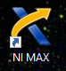

**Figure 3 NI MAX Icon**

8. A window panel similar to that shown in **Figure 4** should now be displayed.

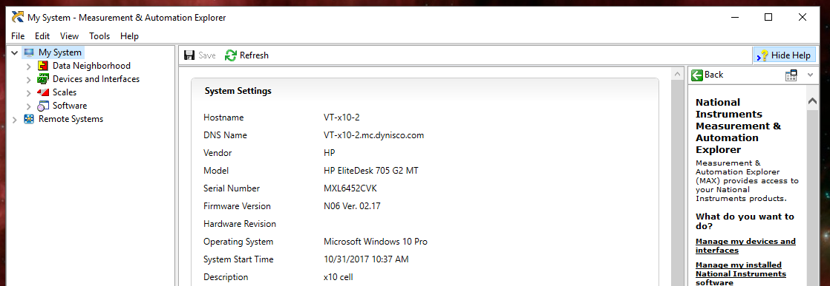

**Figure 4 Measurement and Automation Explorer Start Screen**

9. Expand **My System→Devices and Interfaces** and click on “**NI USB-6009”** in the left window pane. (See **Figure 5**)

10. The status shown in the right window pane should be “**Present”** and a “**Serial Number**” should be displayed.

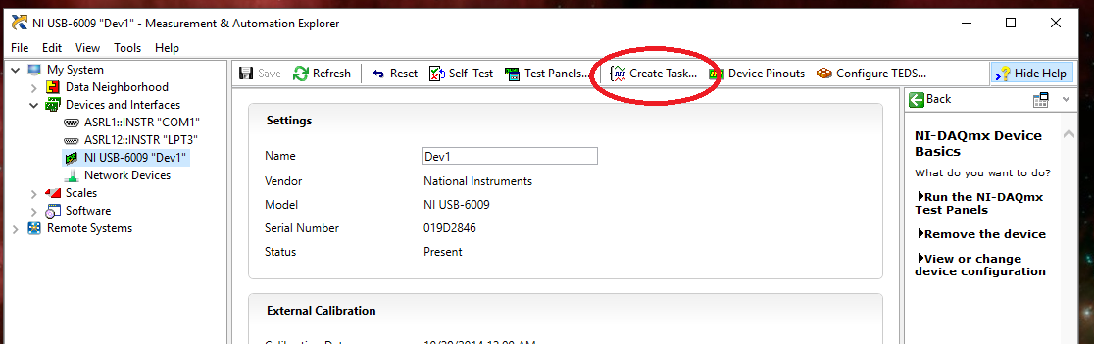

**Figure 5 Verify NI USB-6009 is present**

# Task Setup

## Create an Output Task

11.  Click on “**Create Task**” in the menu bar at the top of the right window pane. The window panel shown in **Figure 6** will be displayed.

12. Expand “**Generate Signals**”.

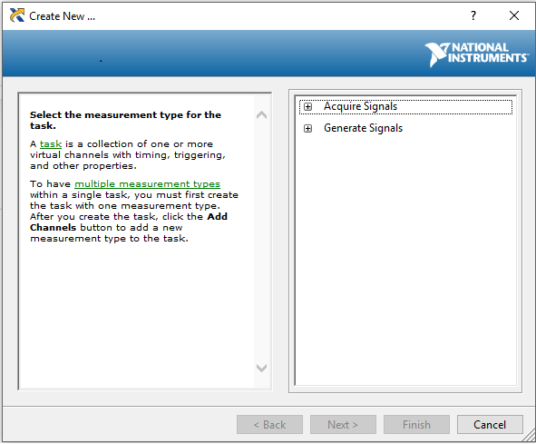

**Figure 6 Create New**

13.  The window panel in **Figure 7** should now be displayed.  Expand “**Digital Output**” → “**Port Output**”.

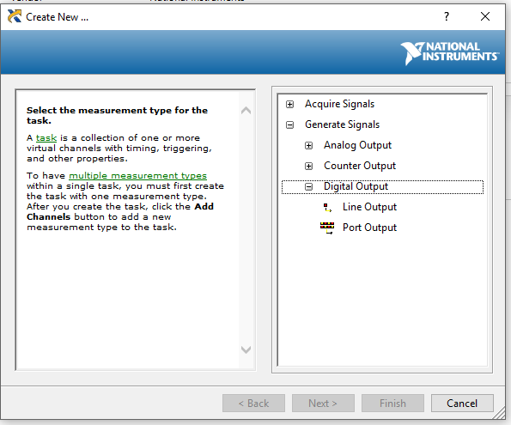

**Figure 7 Create New → Digital Output**

14. The window panel in **Figure 8** should now be displayed.  Click on “**port0**”, then “**Next**”.

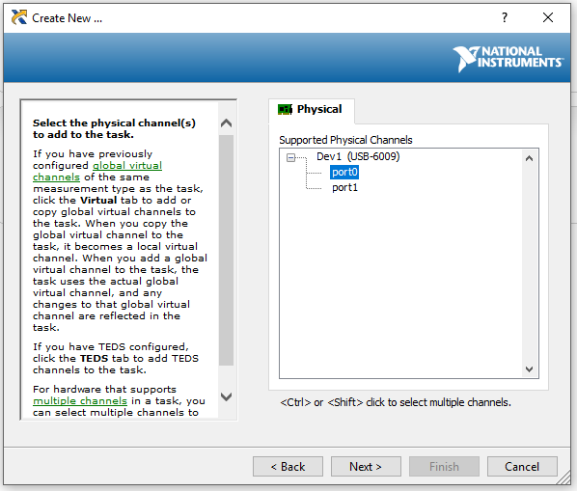

**Figure 8 Create New → Channel**

15.  The window panel Figure 9 should now be displayed.  Enter the task name “Port0_Out”, then click “Finish”.

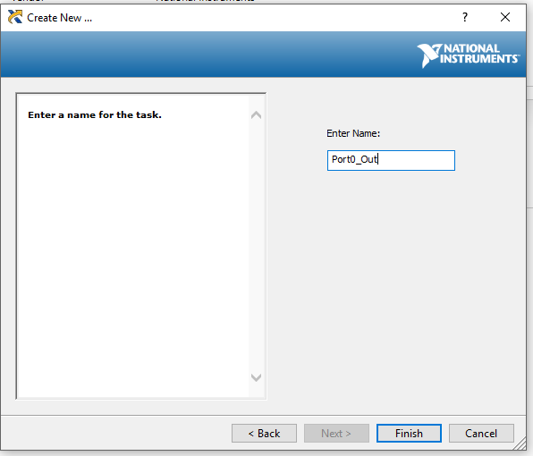

**Figure 9 Create New → Port0_Out**

## Create an Input Task

16.  In the screen titled “**NI USB-6009 “Dev1” Measurement and Automation Explorer**” , click on “**Create Task**” in the menu bar at the top of the right window pane. (**Figure 10**)



**Figure 10 Create Task**

17. Expand “**Generate Signals**”.

18. Click on the “ **+** “ next to “**Acquire Signals**” to expand the menu tree.  Expand “**Digital Input → Port Input**”. (**See Figure 11**)

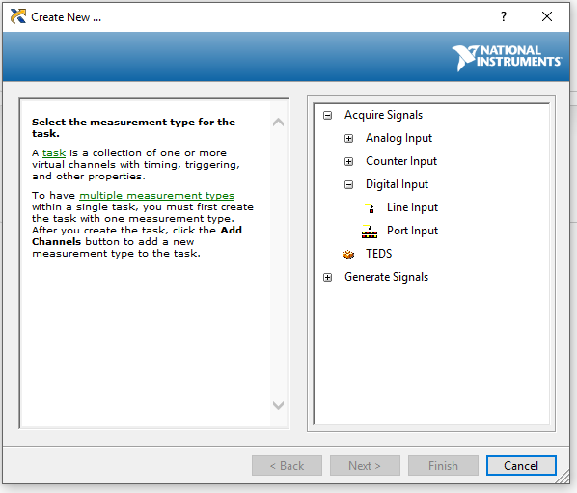

**Figure 11 Acquire Signals -→Digital Input → Port Input**

19.  Click on “**port1**”, then “**Next**”. (**Figure 12**)

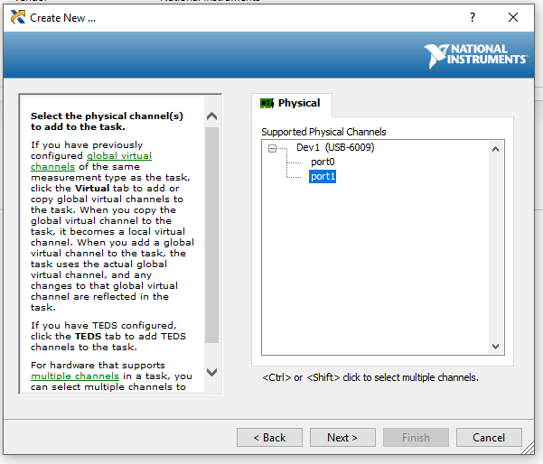

**Figure 12 Create New → Channel**

20.  The window panel in **Figure 13** should be displayed. Enter the task name “**Port1_In**” , then click **“Finish’**.

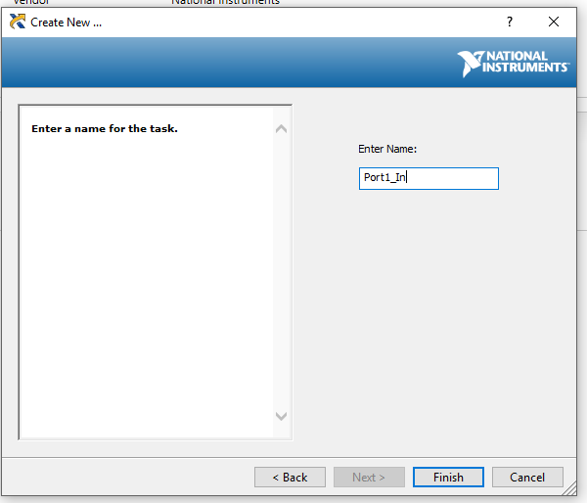

**Figure 13 Create New → Port1_In**

21.   Two new tasks should now be setup.  To verify the tasks exist, expand “**Under Data Neighborhood > NI-DAQmx Tasks**”. “**Port0_Out**” and “**Port1_In**” should be listed. (See **Figure 14**)

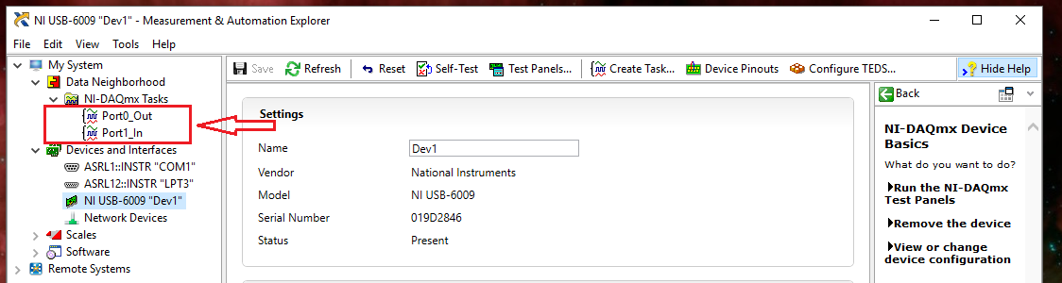

**Figure 14 "Port0_Out" and "Port1_In" Should be Listed**

23. You may exit out of the **MEASUREMENT & AUTOMATION EXPLORER** program at this time.

# 510 Calibration Set-up – “Viatran Adjust” Software

24. Copy the folder named “ **Viatran Adjust**” from the supplied media ( flash drive TL1194.002 ) to the host PC. The folder may be placed directly on the root drive ( C:\ ).

25. The 510 calibration software may be started by double clicking on “**ViaAdjust** “ application.

26. See WI1230 for instructions on using this application.