SW0147 Calibration Software for the Models 510 & 520

Table of Contents
Starting the Software 2
Zero Trim 4
Span Trim 5

Table of Figures
Figure 1 Model 510 & 520 Connections 2
Figure 2 SW0147 Shortcut 3
Figure 3 SW0147 Calibration Interface 3
Figure 4 Zero Trim Buttons 4
Figure 5 Span Trim Buttons 5

Starting the Software
- Connect up to the 5xx, via either flying leads or through the electrical connector on the top of the adapter.
- Connect TL1195 via the cable to the USB port on the computer to be used for calibration. (Figure 1)
- Connect TL1195 via the cable to the five pin header.
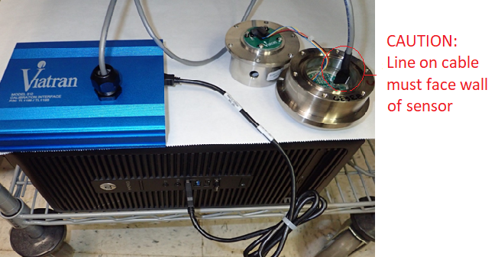
CAUTION: The line on the cable must face the inside wall of the sensor cavity. (Figure 1)
Figure 1 510 & 520 Calibration Setup
- Power the unit on.

- The printed circuit board inside the sensor cavity is marked with the number 2 or the number 5 near the 5 pin header. The boards may also be marked with “5232”, “5235” or have a yellow sticker. Please note this marking or if a sticker is present. This information will be needed in a future step.
- Open SW0147 software from Start menu or the desktop shortcut. (Figure 2)
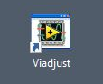
Figure 2 SW0147 Shortcut
- The screen will look similar to Figure 3. The toggle switch outlined in red in Figure 3 should be set as follows…
- Toggle the switch to the left if the number noted from the printed circuit board in step 5 is “2”, “5232” or if a yellow sticker is present.
- Toggle the switch to the right if the number noted from the printed circuit board in step 5 is “5” or “5235”.

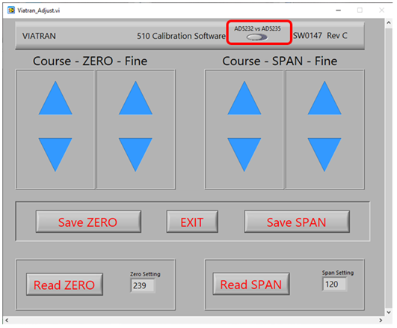
Figure 3 SW0147 Calibration Interface
Zero Trim
- The “Coarse – ZERO - Fine”, “Save ZERO” and “Read ZERO” buttons may be used to trim the zero. All are described in this section.
CAUTION: The zero should be trimmed in at “zero” pressure.

- There are coarse and fine adjustments available to trim the zero. They are in the box under the label “Coarse – ZERO - Fine”. The zero may be moved up and down in large or small steps by clicking on the up or down arrows in the left and right boxes, respectively. Click a button to make the desired adjustments. (See Figure 4)
- Click the “Save ZERO” button below this section to save the changes to the zero.
NOTE: If the “Save ZERO” operation is not performed, the new settings will be lost when power is removed.
- The current device setting may be read by pressing the button labeled “Read ZERO”. The set value may be any value between 0 and 1023 and may be used as a reference when adjusting the zero.
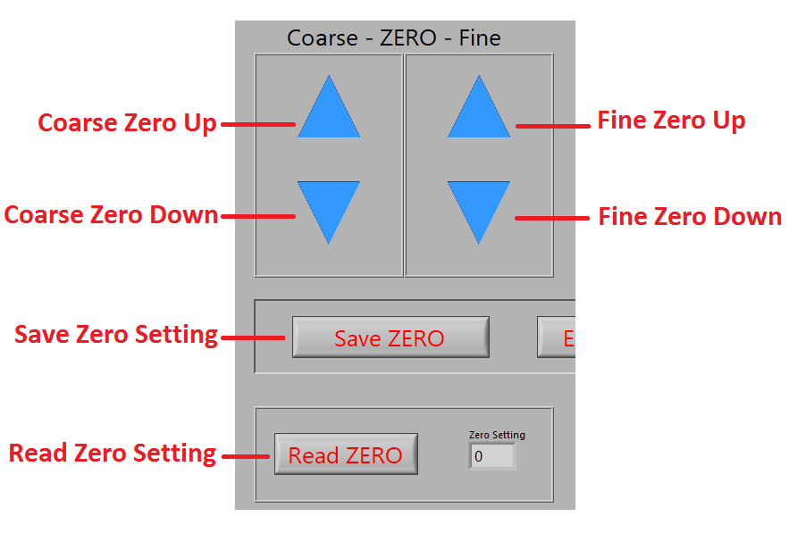
Figure 4 Zero Trim Buttons

Span Trim
- The “Coarse – SPAN - Fine”, “Save SPAN” and “Read SPAN” buttons may be used to trim the span. All are described in this section.
CAUTION: The span should be trimmed in with full-scale pressure applied to the unit.

- There are coarse and fine adjustments available to trim the span. They are in the box under the label “Coarse – SPAN - Fine”. The span may be moved up and down in large or small steps by clicking on the up or down arrows in the left and right boxes, respectively. Click a button to make the desired adjustments. (See Figure 5)
- Click the “Save SPAN” button below this section to save the changes to the span.
NOTE: If the “Save SPAN” operation is not performed, the new settings will be lost when power is removed.
- The current device setting may be read by pressing the button labeled “Read SPAN”. The set value may be any value between 0 and 1023 and may be used as a reference when adjusting the span.

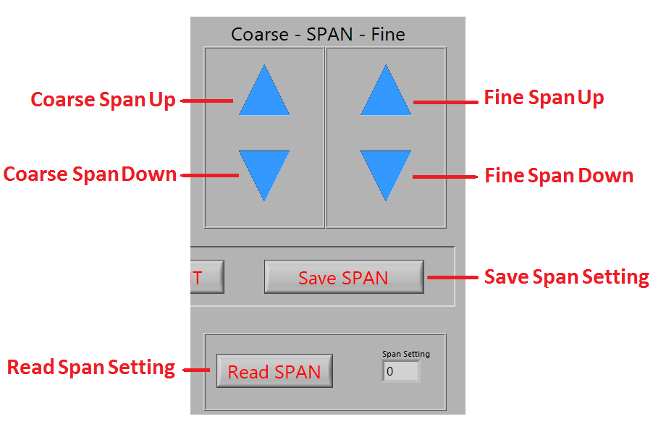
Figure 5 Span Trim Buttons

