510 Calibration Software Installation Update

NOTE: Do not connect 510 Calibration box, TL1195, until the LV19 Runtime environment is installed.
(Install time for LV19 Runtime may take up to 15 minutes)

NOTE: Installation update requires an internet connection.

NOTE: This instruction is for updating the model 510 “Viatran Adjust” software, SW0147, revision B or earlier. Labview Runtime Engine version 13 is installed with previous versions of SW0147. This instruction requires that a previous a version of Labview Runtime be installed on your computer. If this is a fresh install, please refer to WI1229.
Table of Contents
LV19 Runtime Environment Installation 2
510 Calibration Interface Installation 3
510 Calibration Set-up – “Viatran Adjust” Software 4

Table of Figures
Figure 1 Labview Runtime Engine Download Screen 2
Figure 2 USB-6009 in Device Manager 3

LV19 Runtime Environment Update
- The Labview 19 runtime environment (LV19 RTE) update may be installed offline using Viatran USB stick TL1394 or on-line from the National Instruments website.

Off-line Update (requires Viatran TL1394):
- Extract the file “LV19 SP1 RTE for Offline Installation” from the supplied USB stick, TL1394, to the target computer.
- Navigate to the directory of extracted files on the target computer.
- Double click on the file “ni=labview-2019-runtime-engine-x86_19.1_offline” in the directory of extracted files to begin the installation.
- Continue at step 4.
On-line Update: Navigate to the following website by clicking on the link or copy and pasting in your browser.
https://www.ni.com/en-us/support/downloads/software-products/download.labview.html#346878

Continue with step 2.

- The link will take you to a web page similar to Figure 1. Make the selections indicated in the red boxes in Figure 1. When you have made these selections, press the “DOWNLOAD” button shown next to the red arrow in the figure.

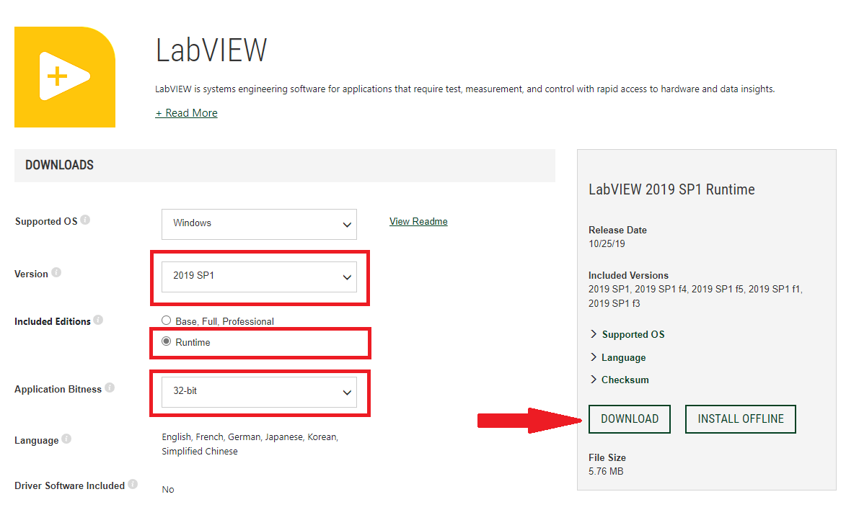
Figure 1 Labview Runtime Engine Download Screen
- NI Package Manager is required to install Labview software. If your computer does not already have NI Package Manger, it will be downloaded automatically during the LV19 installation process. You will need to run the downloaded executable file to launch the NI Package Manager and install the software. This is done by navigating to the Downloads folder in File Explorer and double clicking on the downloaded file “ni-labview-2019-runtime-engine-x86_19.0_online_repack3”.

- If applicable, accept the license agreement for the NI Package Manager at the prompt and click “Next” and “Next” again.

- The license agreement for Labview Runtime will appear. Accept the license agreement at the prompt, click “Next” and “Next” again.
6. When prompted restart computer to successfully complete installation.

510 Calibration Interface Installation
7. Attach 510 Calibration Box to the computer via USB Cable.
- Using the Device Manager, find the category labelled “Data Acquisition Devices”

- Expand “Data Acquisition Devices” and verify “USB-6009” is listed. (See Figure 2)

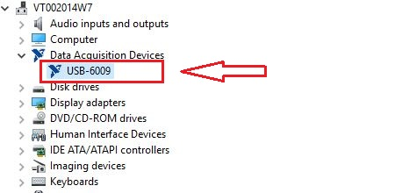
Figure 2 LabUSB-6009 in Device Manager

- If USB-6009 is not listed, see WI1229.

510 Calibration Set-up – “Viatran Adjust” Software

11. The “Viatran Adjust” software, SW0147, may have been supplied on a flash drive as TL1394, downloaded from the Viatran website or via email. Copy the file or folder named “ Viatran Adjust” to the host PC. If the software is in condensed format such as a zip file, it should be extracted. The extracted folder may be placed directly on the root drive ( C:\ ).

12. The 510 calibration software may be started by double clicking on “ViaAdjust “ application.

13. See WI1230 for instructions on using this application.

